Angular Tic-tac-toe

Note: Please use chrome for running the application you might need to install the chrome plugin to avoid the CORS issue.

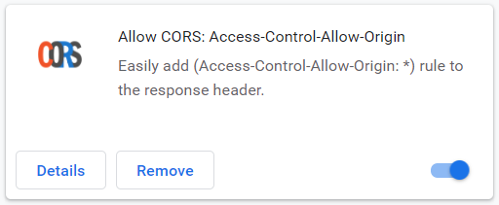

Open the tic-tac-toe web api in visual studio then run it.

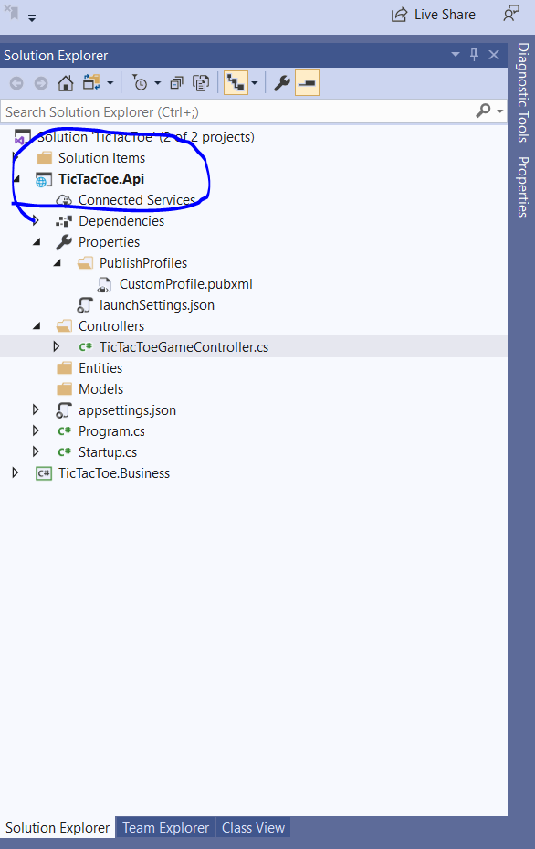

First screen of the Tictactoe

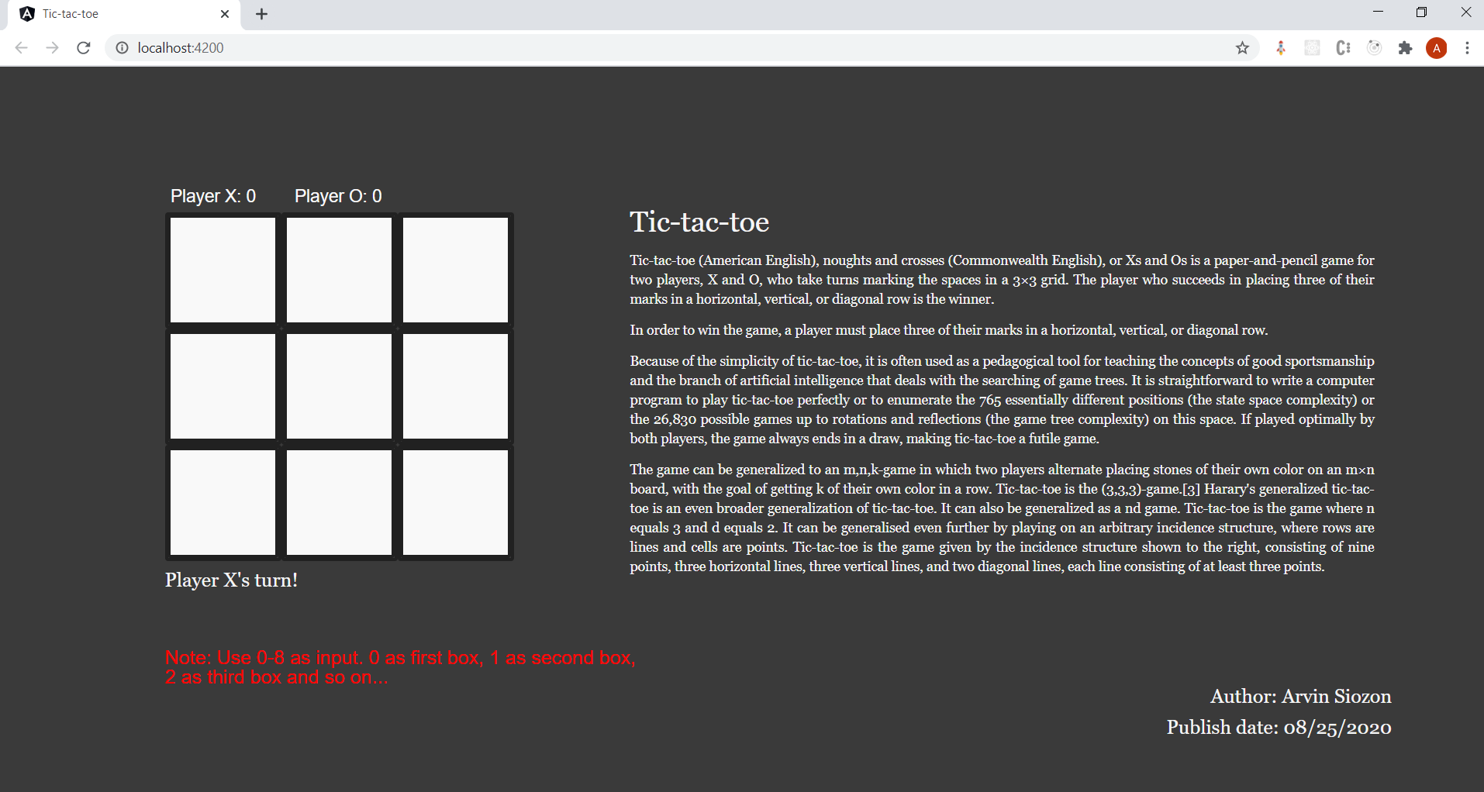

In this session Player X won the game. If you click play again, the board game will be reset but will retain the current score in the score board.

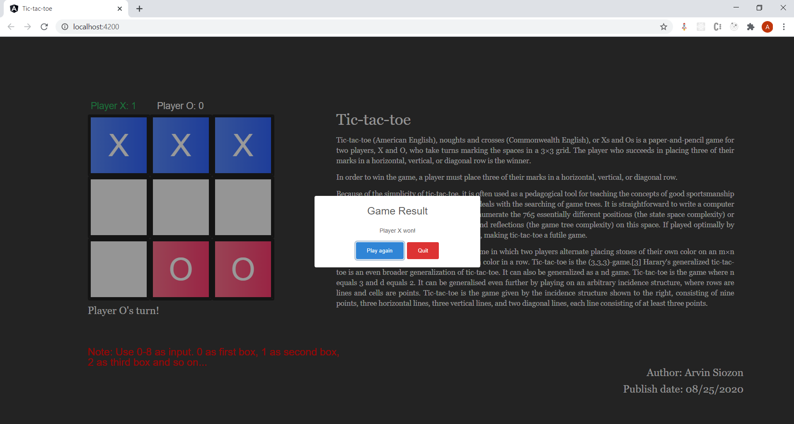

In this session Player O won the game

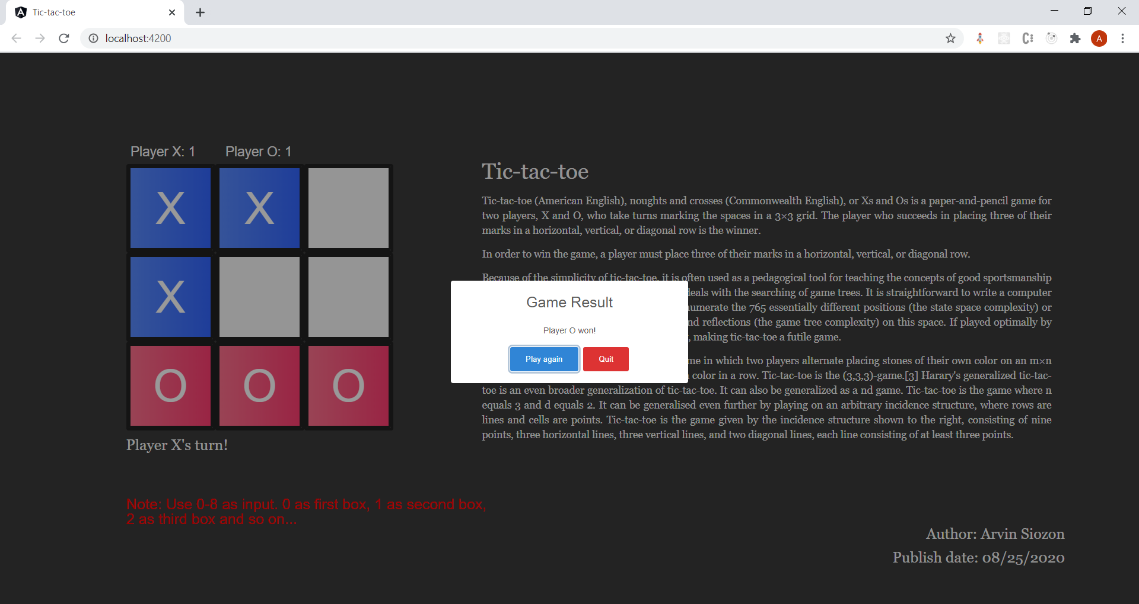

In this session it is a draw and shows the “Cat’s game!” message

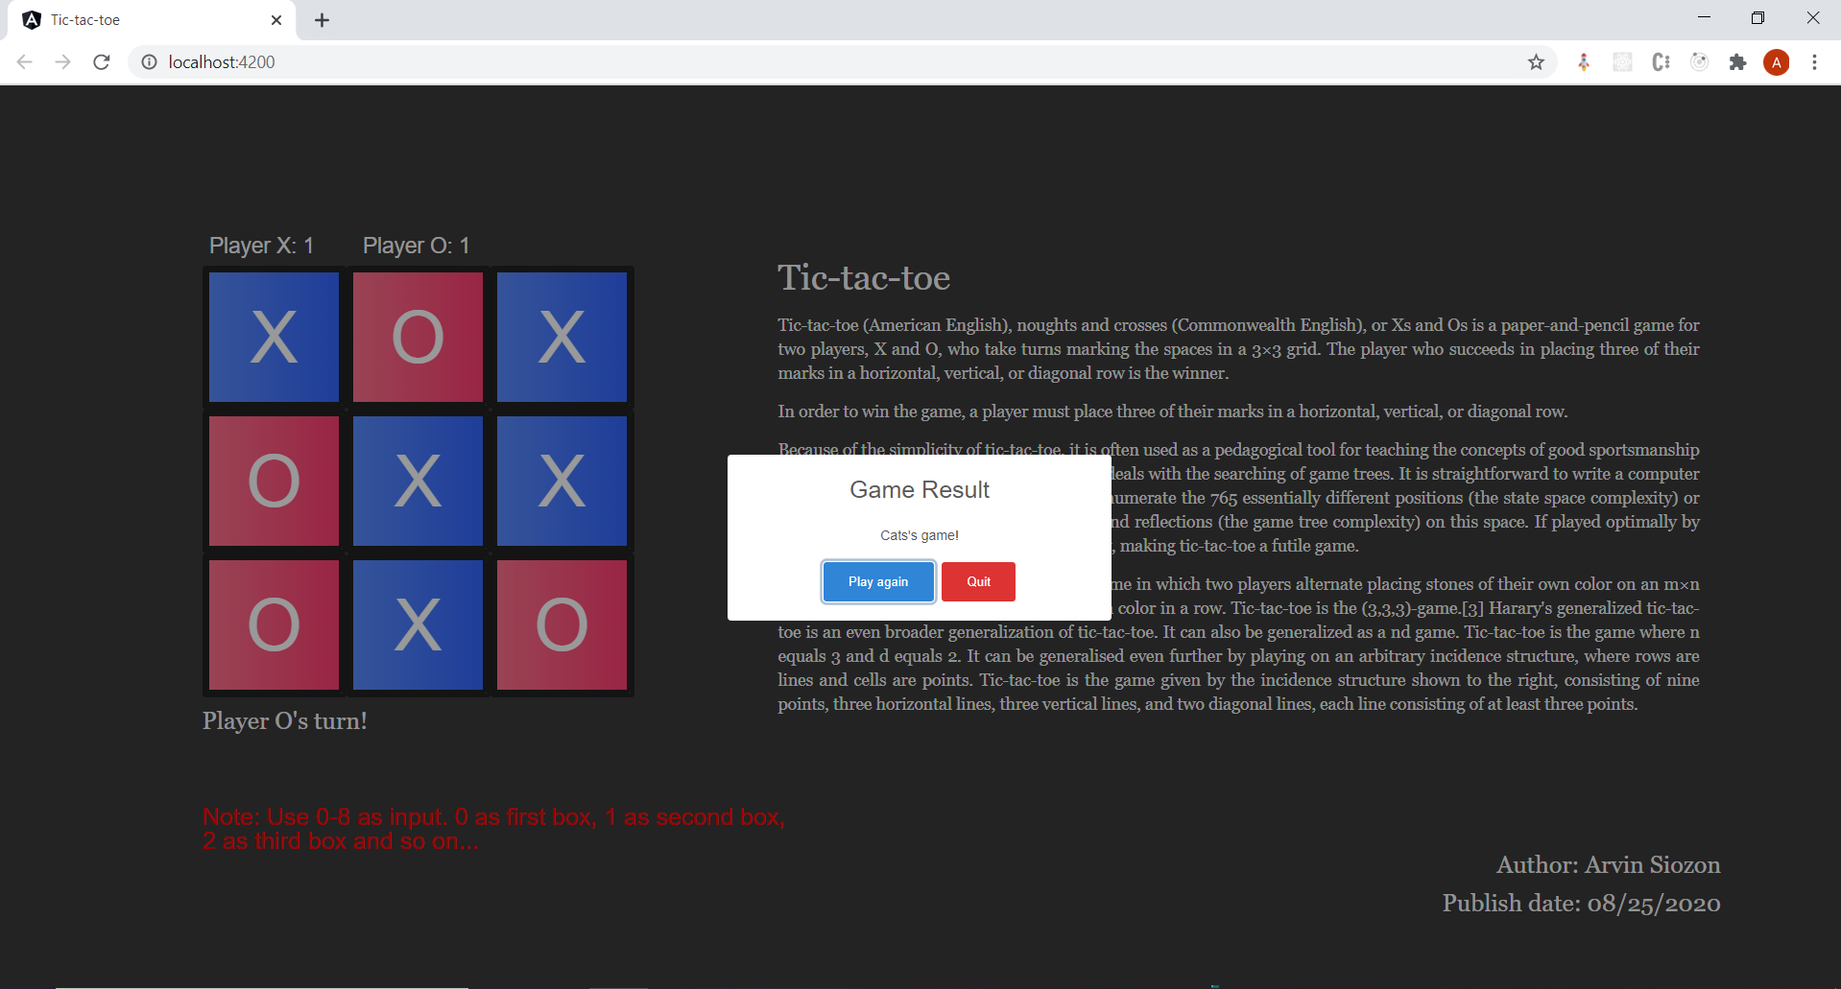

If you click Quit the board game and score board will be reset.

